April 6, 2023
Ref: IIH/MD/2023/04/003

His Excellency,
The Executive Governor of Kwara State,
Government House,
Ahmadu Bello Way,
GRA, Ilorin, Kwara State

Your Excellency Sir,
REQUEST FOR APPROVAL TO USE KWARA STATE BANQUET HALL FOR 1-WEEK ARTIFICIAL INTELLIGENCE TRAINING PROGRAM
I am writing to request your approval to use the Kwara State Banquet Hall for a training program by Data Science Network called AI Invasion - Free AI Classes In Every City. The training program is scheduled to hold all week from Monday April 24th to Friday April 28th, from 9am to 1 pm each day.

The program is designed to offer free classes in Artificial Intelligence to interested participants in Kwara State. It is an initiative aimed at promoting digital literacy and equipping individuals with the necessary skills to succeed in the digital economy.

We believe that the Kwara State Banquet Hall is an ideal venue for the training program, given its central location, ample space, and state-of-the-art facilities. It will provide a conducive learning environment for participants and enable us to achieve our objectives.

We appreciate your continued support towards promoting innovation and entrepreneurship in Kwara State, and we believe that this training program will contribute to your vision for a digitally literate and prosperous Kwara State.

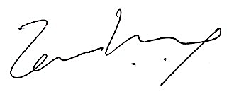
Thank you for considering our request. We look forward to your positive response.
Best regards,

Temi Kolawole
Managing Director

